Segment–Ray Collinearity
# Source: AI Source: Provided by: [Data Path: Persons Table -> ID Column: 1, Name_En Column: Motasem Essam] -> From: [ChatGPT] on [7/25/2026]
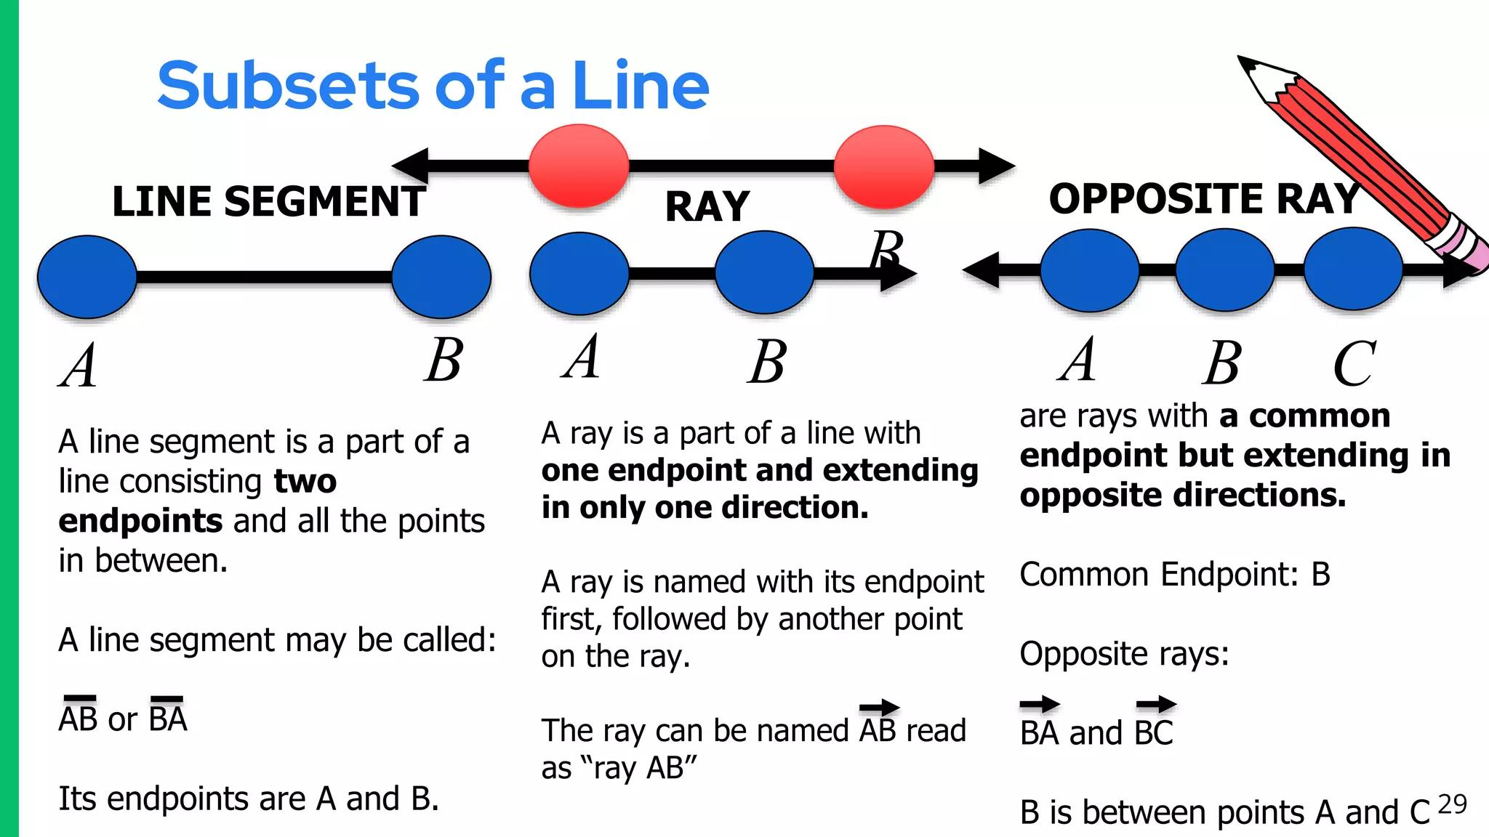
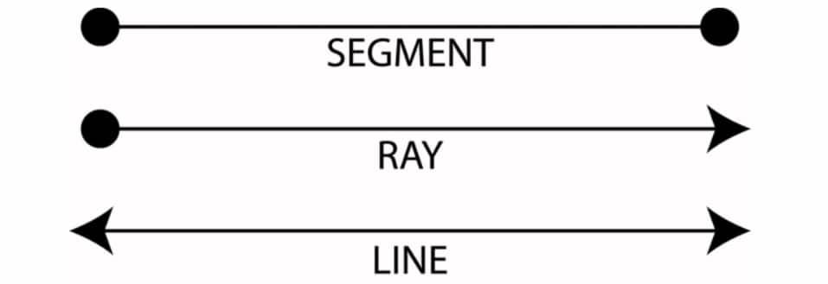
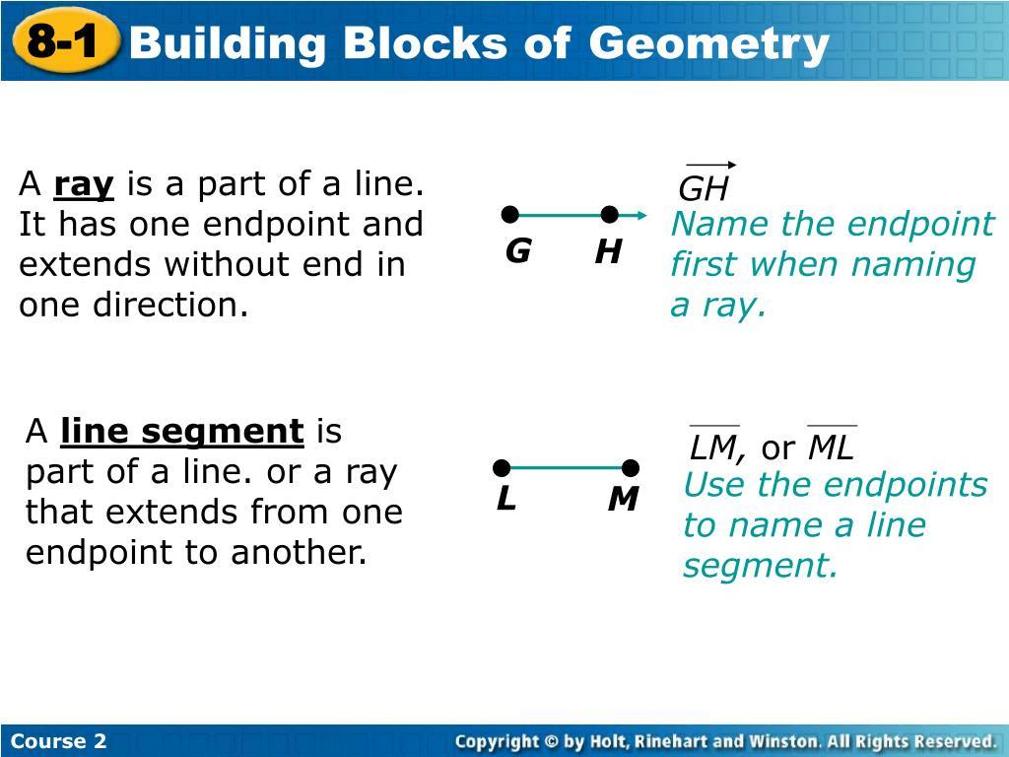

Definition
# Source: AI Source: Provided by: [Data Path: Persons Table -> ID Column: 1, Name_En Column: Motasem Essam] -> From: [ChatGPT] on [7/25/2026]
Segment–Ray Collinearity is a geometric relationship in which a line segment and a ray lie on the same supporting straight line.
For a segment $\overset{‾}{AB}$and a ray $\vec{CD}$, they are segment–ray collinear if there exists a line $l$such that:
$$\overset{‾}{AB}⊆l$$
and
$$\vec{CD}⊆l$$
Thus, the segment and ray have the same supporting line.
Collinearity does not require the segment and ray to overlap or touch. They can be separated along the same line.

Basic Representation
# Source: AI Source: Provided by: [Data Path: Persons Table -> ID Column: 1, Name_En Column: Motasem Essam] -> From: [ChatGPT] on [7/25/2026]
Segment and Ray with the Same Supporting Line
A ●────────────● B──────C ●────────────────────▶
D
The segment and ray lie on the same straight line:
$$\overset{‾}{AB}⊆l \\ \vec{CD}⊆l$$
Therefore, they are collinear, even though they do not necessarily share points.

Fundamental Concept
# Source: AI Source: Provided by: [Data Path: Persons Table -> ID Column: 1, Name_En Column: Motasem Essam] -> From: [ChatGPT] on [7/25/2026]
A segment and a ray differ in their extent.
Segment
$$\overset{‾}{AB}$$
has two endpoints and finite length:
A ●────────────────● B
Ray
$$\vec{CD}$$
has one endpoint and extends infinitely in one direction:
C ●──────────────────────────────▶
For segment–ray collinearity, both must lie on the same supporting line:
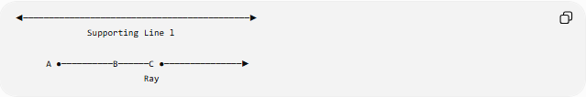
◀────────────────────────────────────────────▶
Supporting Line l

A ●──────────B──────C ●───────────────▶
Ray

Mathematical Representation
# Source: AI Source: Provided by: [Data Path: Persons Table -> ID Column: 1, Name_En Column: Motasem Essam] -> From: [ChatGPT] on [7/25/2026]
Let the segment be:
$$\overset{‾}{AB}$$
and the ray be:
$$\vec{CD}$$
Segment–ray collinearity requires:
$$\boxed{A,B,C,D∈l}$$
for one common line $l$.
Equivalently:
$$\boxed{\overset{‾}{AB}⊆l \text{and} \vec{CD}⊆l}$$

Important Distinction: Collinearity vs. Intersection
# Source: AI Source: Provided by: [Data Path: Persons Table -> ID Column: 1, Name_En Column: Motasem Essam] -> From: [ChatGPT] on [7/25/2026]
A segment and a ray can be collinear without intersecting.
Separated
A ●────────● B C ●────────────────────▶
They have:
$$\overset{‾}{AB}∩\vec{CD}=∅$$
but both lie on the same supporting line.
Therefore, they are still segment–ray collinear.
This is an important distinction:
$$\boxed{\text{Collinearity}≠\text{Intersection}}$$

Types of Segment–Ray Collinear Position
# Source: AI Source: Provided by: [Data Path: Persons Table -> ID Column: 1, Name_En Column: Motasem Essam] -> From: [ChatGPT] on [7/25/2026]
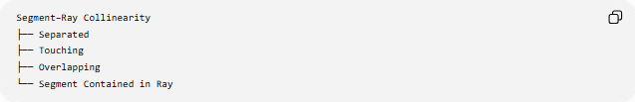
Segment–Ray Collinearity
├── Separated
├── Touching
├── Overlapping
└── Segment Contained in Ray
These describe the additional positional relationship between the two collinear objects.

1. Separated Segment and Ray
# Source: AI Source: Provided by: [Data Path: Persons Table -> ID Column: 1, Name_En Column: Motasem Essam] -> From: [ChatGPT] on [7/25/2026]
A ●────────────● B C ●──────────────────▶
The segment lies entirely away from the ray's endpoint and its extent.
$$\overset{‾}{AB}∩\vec{CD}=∅$$
They are nevertheless collinear.

2. Touching Segment and Ray
# Source: AI Source: Provided by: [Data Path: Persons Table -> ID Column: 1, Name_En Column: Motasem Essam] -> From: [ChatGPT] on [7/25/2026]
A ●────────────● B=C ●───────────────────────▶
The segment's endpoint coincides with the ray's endpoint:
$$B=C$$
Therefore:
$$\overset{‾}{AB}∩\vec{CD}=\left\{C\right\}$$
They share exactly one point.

3. Overlapping Segment and Ray
# Source: AI Source: Provided by: [Data Path: Persons Table -> ID Column: 1, Name_En Column: Motasem Essam] -> From: [ChatGPT] on [7/25/2026]
A ●────────C ●──────B────────────────────────▶
D
Part of the segment lies within the ray.
For example:
$$A<C<B$$
with ray:
$$\vec{CD}$$
extending from $C$through $D$.
Their common portion has positive length:
$$length⁡\left(\overset{‾}{AB}∩\vec{CD}\right)>0$$

4. Segment Contained in the Ray
# Source: AI Source: Provided by: [Data Path: Persons Table -> ID Column: 1, Name_En Column: Motasem Essam] -> From: [ChatGPT] on [7/25/2026]
C ●────────A ●────────────● B───────────────▶
The entire segment belongs to the ray:
$$\boxed{\overset{‾}{AB}⊆\vec{CD}}$$
This is a special containment case of segment–ray collinearity.

Parametric Representation
# Source: AI Source: Provided by: [Data Path: Persons Table -> ID Column: 1, Name_En Column: Motasem Essam] -> From: [ChatGPT] on [7/25/2026]
A common supporting line can be represented as:
$$r\left(t\right)=A+tv$$
where:
$$t∈R$$
Different ranges of $t$describe different linear objects.
Segment
For $\overset{‾}{AB}$:
$$0≤t≤1$$
Ray
For $\vec{CD}$:
$$t≥0$$
after choosing the appropriate endpoint and direction.
Thus, segment–ray collinearity means that both objects can be represented using the same supporting line, although their parameter ranges are different.

Coordinate Example
# Source: AI Source: Provided by: [Data Path: Persons Table -> ID Column: 1, Name_En Column: Motasem Essam] -> From: [ChatGPT] on [7/25/2026]
Consider the segment:
$$A=\left(1 , 4\right) \\ B=\left(7 , 4\right)$$
and the ray:
$$\vec{CD}$$
where:
$$C=\left(10 , 4\right) \\ D=\left(15 , 4\right)$$
All four points satisfy:
$$y=4$$
Therefore:
$$\overset{‾}{AB}⊆\left(y=4\right)$$
and:
$$\vec{CD}⊆\left(y=4\right)$$
Hence the segment and ray are collinear.
They are also separated because:
$$7<10$$
so:
$$\overset{‾}{AB}∩\vec{CD}=∅$$

Coordinate Example: Touching
# Source: AI Source: Provided by: [Data Path: Persons Table -> ID Column: 1, Name_En Column: Motasem Essam] -> From: [ChatGPT] on [7/25/2026]
Let:
$$A=\left(1 , 4\right) \\ B=\left(7 , 4\right)$$
and:
$$C=\left(7 , 4\right)$$
with ray:
$$\vec{CD}$$
extending toward increasing $x$.
Then:
$$B=C$$
and:
$$\overset{‾}{AB}∩\vec{CD}=\left\{\left(7 , 4\right)\right\}$$
Therefore, the segment and ray are:
- Collinear
- Touching
- Not overlapping over a positive length

Coordinate Example: Overlapping
# Source: AI Source: Provided by: [Data Path: Persons Table -> ID Column: 1, Name_En Column: Motasem Essam] -> From: [ChatGPT] on [7/25/2026]
Let:
$$A=\left(1 , 4\right) \\ B=\left(9 , 4\right)$$
and:
$$C=\left(5 , 4\right)$$
with ray:
$$\vec{CD}$$
extending toward increasing $x$.
Then:
A ●────────C ●────────B──────────────────────▶
The common portion is:
$$\overset{‾}{CB}$$
and therefore:
$$length⁡\left(\overset{‾}{AB}∩\vec{CD}\right)=4$$
The segment and ray are overlapping collinear objects.

Direction Matters for a Ray
# Source: AI Source: Provided by: [Data Path: Persons Table -> ID Column: 1, Name_En Column: Motasem Essam] -> From: [ChatGPT] on [7/25/2026]
A ray is not determined only by its supporting line.
For example:
$$\vec{AB}$$
and:
$$\vec{BA}$$
are different rays.
They have the same supporting line:
$$\overset{↔}{AB}$$
but extend in opposite directions.
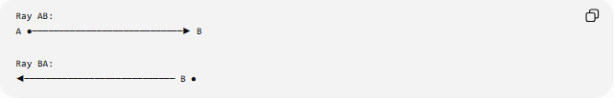
Ray AB:
A ●────────────────────────────▶ B

Ray BA:
◀──────────────────────────── B ●
Therefore, when determining whether a segment overlaps a ray, the direction of the ray must be considered.

Segment Contained in a Ray
# Source: AI Source: Provided by: [Data Path: Persons Table -> ID Column: 1, Name_En Column: Motasem Essam] -> From: [ChatGPT] on [7/25/2026]
Suppose:
$$\overset{‾}{AB}$$
lies entirely in the direction of:
$$\vec{CD}$$
Then:
$$\boxed{\overset{‾}{AB}⊆\vec{CD}}$$
This is stronger than merely saying that the objects are collinear.
The relationship hierarchy becomes:
$$\text{Segment–Ray Collinearity}$$
followed by the additional condition:
$$\text{Segment–Ray Containment}$$

Collinearity Test
# Source: AI Source: Provided by: [Data Path: Persons Table -> ID Column: 1, Name_En Column: Motasem Essam] -> From: [ChatGPT] on [7/25/2026]
If the segment endpoints and two points defining the ray are given in coordinates, all relevant points must lie on the same line.
For example, for:
$$A=\left(x_{1} , y_{1}\right), B=\left(x_{2} , y_{2}\right), C=\left(x_{3} , y_{3}\right)$$
a collinearity test is:
$$\boxed{\left(x_{2}-x_{1}\right)\left(y_{3}-y_{1}\right)-\left(y_{2}-y_{1}\right)\left(x_{3}-x_{1}\right)=0}$$
A fourth point $D$must also satisfy the same common-line condition.
Thus:
$$A,B,C,D∈l$$
for one line $l$.

Relationship to Incidence
# Source: AI Source: Provided by: [Data Path: Persons Table -> ID Column: 1, Name_En Column: Motasem Essam] -> From: [ChatGPT] on [7/25/2026]
Segment–ray collinearity should be distinguished from incidence.
Collinearity
Focuses on:
$$\overset{‾}{AB},\vec{CD}⊆l$$
Incidence / Intersection
Focuses on whether the objects share points:
$$\overset{‾}{AB}∩\vec{CD}≠∅$$
Therefore, two segment–ray objects may be collinear while having:
$$\overset{‾}{AB}∩\vec{CD}=∅$$

Relationship to Containment
# Source: AI Source: Provided by: [Data Path: Persons Table -> ID Column: 1, Name_En Column: Motasem Essam] -> From: [ChatGPT] on [7/25/2026]
If:
$$\overset{‾}{AB}⊆\vec{CD}$$
then the segment is contained in the ray.
Containment automatically implies collinearity:
$$\boxed{\overset{‾}{AB}⊆\vec{CD}⇒\overset{‾}{AB}\text{ and }\vec{CD}\text{ are collinear}}$$
But collinearity does not imply containment.

Comparison with Other Line-Object Relationships
# Source: AI Source: Provided by: [Data Path: Persons Table -> ID Column: 1, Name_En Column: Motasem Essam] -> From: [ChatGPT] on [7/25/2026]
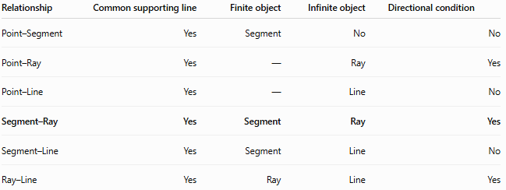
Relationship | Common supporting line | Finite object | Infinite object | Directional condition
Point–Segment | Yes | Segment | No | No
Point–Ray | Yes | — | Ray | Yes
Point–Line | Yes | — | Line | No
Segment–Ray | Yes | Segment | Ray | Yes
Segment–Line | Yes | Segment | Line | No
Ray–Line | Yes | Ray | Line | Yes

Important Properties
# Source: AI Source: Provided by: [Data Path: Persons Table -> ID Column: 1, Name_En Column: Motasem Essam] -> From: [ChatGPT] on [7/25/2026]
- A segment and ray must lie on the same supporting line.
- They may be separated, touching, overlapping, or one may contain the other.
- Collinearity alone does not require intersection.
- The ray's direction matters when determining overlap or containment.
- A segment contained in a ray is automatically segment–ray collinear.
- A touching segment and ray have a zero-length intersection.
- An overlapping segment and ray have a positive-length intersection.
- A separated segment and ray have an empty intersection.
- Segment–ray collinearity is a special case of Line-Object Collinearity.

Taxonomy
# Source: AI Source: Provided by: [Data Path: Persons Table -> ID Column: 1, Name_En Column: Motasem Essam] -> From: [ChatGPT] on [7/25/2026]
Geometric Relationships
└── Collinearity
└── Line-Object Collinearity
├── Point–Segment Collinearity
├── Point–Ray Collinearity
├── Point–Line Collinearity
├── Segment–Ray Collinearity
├── Segment–Line Collinearity
└── Ray–Line Collinearity

Key Points
# Source: AI Source: Provided by: [Data Path: Persons Table -> ID Column: 1, Name_En Column: Motasem Essam] -> From: [ChatGPT] on [7/25/2026]
- Segment–Ray Collinearity means a segment and a ray lie on the same supporting straight line.
- The segment is finite:
$$\overset{‾}{AB}$$
- The ray is infinite in one direction:
$$\vec{CD}$$
- They can be separated without losing collinearity.
- They can touch at one point.
- They can overlap over a positive-length portion.
- One can be completely contained within the ray.
- The ray's direction is important for determining its actual extent.

Conclusion
# Source: AI Source: Provided by: [Data Path: Persons Table -> ID Column: 1, Name_En Column: Motasem Essam] -> From: [ChatGPT] on [7/25/2026]
Segment–Ray Collinearity describes the common straight-line alignment of a finite segment and a one-directionally infinite ray. The two objects do not need to intersect; their defining condition is that both lie on the same supporting line. Once this collinearity is established, their additional positional relationship can be classified as separated, touching, overlapping, or containment.

